Art Gallery 3D Project
Ishrat Sikder (Scrum Master)
Amir Hossein Danesh (Developer)
Ekemini John (Developer)
Jay Dodd (Developer)
Serge Rumyantsev

University of Windsor
COMP-2800
Professor Xiaobu Yuan
April 4, 2025

Signatures
Ishrat Sikder | Amir Danesh | Jay Dodd | Ekemini John

Statement of Honesty: In submitting this team project and report, we confirm that our conduct during this project adheres to the Student Code of Conduct. We confirm that we did NOT act in such a way that would constitute cheating, misrepresentation, or unfairness, including but not limited to, using unauthorized aids and assistance, personating other persons, and committing plagiarism.
Introduction
Since ancient times, art has been a powerful means of storytelling, preserving history, culture, and creativity across generations. Museums and galleries have long served as gateways to these artistic expressions, allowing people to experience and appreciate masterpieces from around the world. With advancements in technology, virtual reality (VR) is transforming the way art is explored and interacted with, making it more accessible beyond the constraints of physical spaces.
This project aims to develop an interactive VR Art Galler using Java3D, a high-level 3D graphics API for the Java programming language. The virtual museum will allow users to navigate through a square-shaped exhibition space, view digital artworks, and interact with sculptures and displays in a fully immersive 3D environment. By simulating a real-world museum experience, this project demonstrates how VR can bridge the gap between traditional art appreciation and modern digital interaction.
In this report, we will explore the fundamental concepts behind designing a virtual museum, document the development process, and discuss the teamwork and problem-solving strategies used in its creation. This project not only enhances our understanding of computer graphics, object-oriented programming, and interactive design, but also showcases the potential of VR in education, entertainment, and cultural preservation.
  - Purpose of the Project
The purpose of this project is to develop a virtual reality (VR) art museum using Java3D, providing users with an interactive and immersive way to explore digital artwork and sculptures in a 3D environment. By simulating a museum setting, this project aims to enhance the experience of viewing art beyond traditional 2D images, incorporating realistic spatial navigation, textures, lighting, and animations.
Additionally, this project serves as a hands-on learning experience in computer graphics, 3D modeling, user interaction, and scene rendering. Through the implementation of collision detection, object picking, animations, and environment mapping, the project introduces key concepts in game development and virtual simulation.
By completing this project, we aim to deepen our understanding of Java3D, object-oriented programming, and interactive graphics, while also exploring the potential of VR-based applications in education, entertainment, and digital exhibitions.
  - Issues to Be Discussed and Their Significance
One of the primary challenges in developing the VR Art Museum is creating a realistic and immersive 3D environment. The virtual museum must provide an engaging space where users can explore exhibits naturally, making it essential to design accurate walls, flooring, and lighting that contribute to a visually cohesive atmosphere. Ensuring smooth texture mapping for walls and floors is also crucial, as poorly applied textures can break immersion and make the environment feel artificial. Additionally, lighting plays a key role in enhancing realism, influencing the way objects appear within the space. Proper illumination ensures that statues, paintings, and other exhibits are visible with appropriate depth and shadowing.
Navigation within the museum is another significant consideration, requiring careful implementation of movement and collision detection. Users must be able to move smoothly through the environment using keyboard controls while maintaining a natural perspective. Collision detection ensures that they cannot pass through walls or objects, preserving the physical boundaries of the space and enhancing realism. A well-implemented movement system contributes to a more intuitive user experience, allowing seamless exploration of exhibits without abrupt or unnatural transitions.
Beyond navigation, the placement and behavior of objects within the museum add another layer of complexity. Each exhibit, whether a painting on the wall, a statue on display, or a jewel encased in a spinning platform, must be positioned in a way that feels natural and aesthetically pleasing. Animations, such as a rotating display or a morphing statue, introduce dynamic elements that make the space feel interactive and engaging. Properly managing these object behaviors ensures that they complement the overall experience without causing visual distractions or performance issues.
  - Project Methods
The VR Art Museum was developed using Java 3D for modeling the environment, object placement, and navigation. Texture mapping and lighting were applied to enhance realism, while collision detection ensured users could not pass through walls or exhibits. Keyboard-based navigation allowed movement, and picking behavior enabled interaction with objects for additional information. Animated elements, like a rotating jewel display and a morphing statue, were implemented to demonstrate object behavior.
Development was carried out in Eclipse, with 3D models refined in Blender before being imported. Version control was managed via GitHub, and we used Jira to follow Scrum methodology, organizing tasks and tracking progress efficiently. These tools and techniques helped create an engaging and interactive virtual museum while strengthening our skills in 3D graphics and user interaction.
  - Limitations and Assumptions
While developing the VR Art Museum, we made several assumptions to simplify the project scope. The museum was designed with a fixed layout, meaning exhibits and walls cannot be dynamically rearranged. Additionally, collision detection was implemented to prevent movement through objects, but fine-tuned physics interactions, such as realistic object pushing or grabbing, were not included. Another limitation was the complexity of 3D modeling and animation. Due to our skill level and time constraints, we used simplified models and animations rather than highly detailed or procedurally generated assets. Texture quality was optimized for performance, assuming users would run the application on standard consumer hardware without requiring high-end graphics processing.
Furthermore, while Java 3D provided a structured way to create the environment, it has known limitations in modern rendering capabilities compared to more advanced engines like Unity or Unreal Engine. This restricted our ability to implement realistic lighting effects, shadows, and reflections. Despite these constraints, the project successfully demonstrates interactive 3D navigation, object placement, and user interaction within a virtual museum space.
Project Management with Scrum
  - Use Cases and Backlog Items
Case 1:
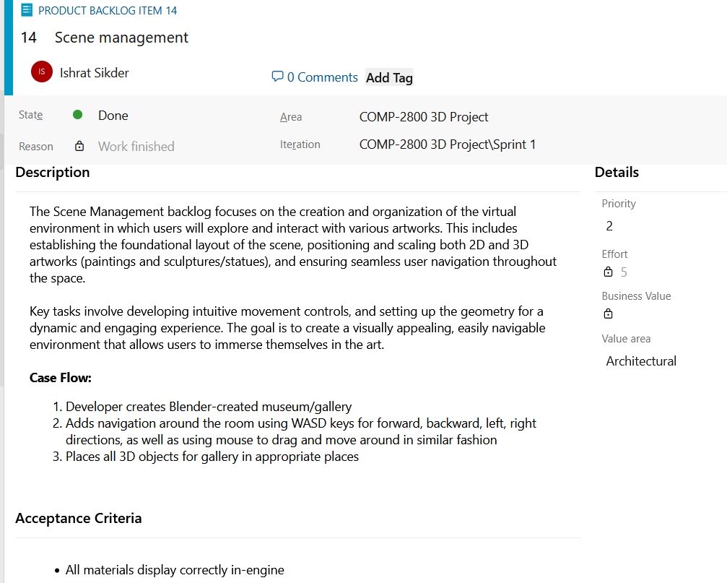

Case 2:
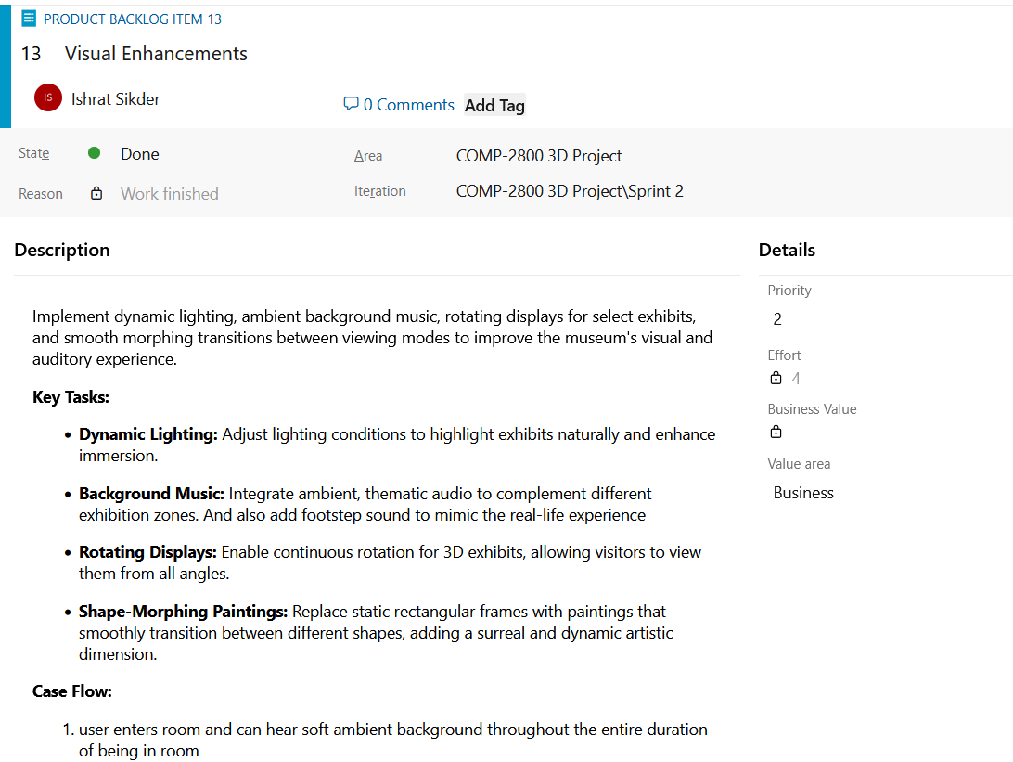
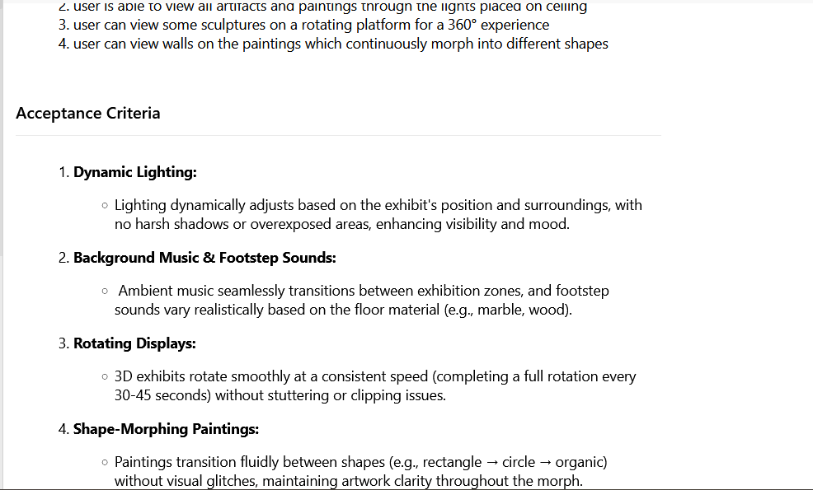
Case 3:
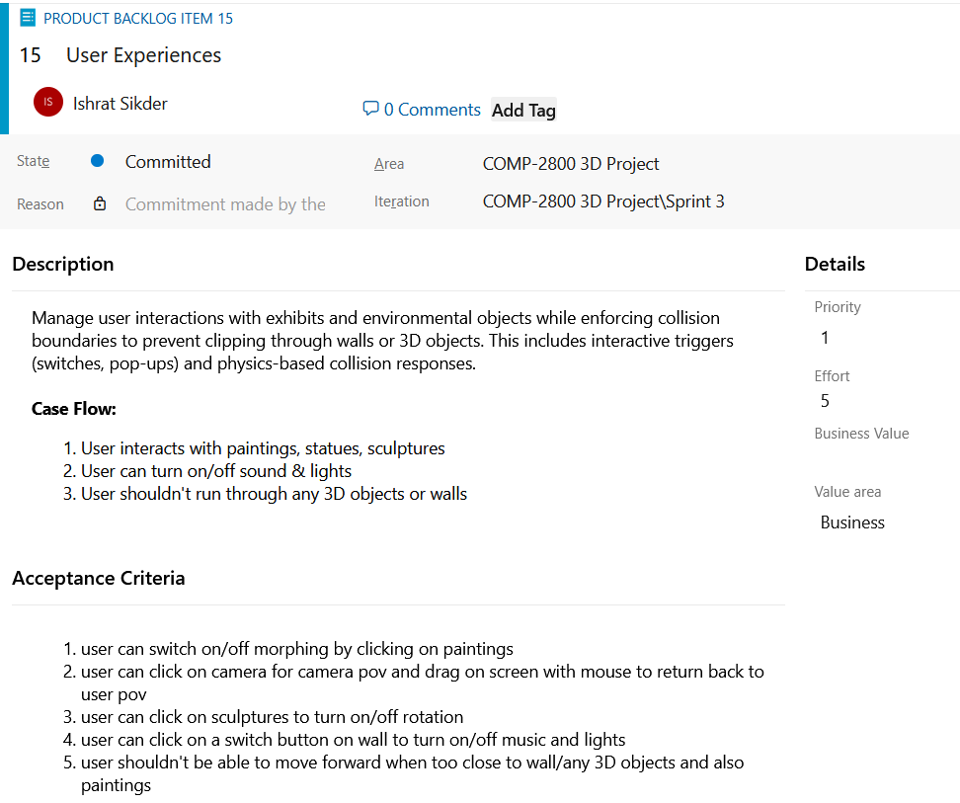

  - Creation of Tasks
For this project we have a total of 9 tasks that needed to be completed. We distributed these tasks among the developers to ensure seamless work progression and timely completion.
By diving tasks, we were able to work together in a structured manner and efficiently complete everyone’s tasks in a timely manner as everyone is assigned a job with a set deadline.
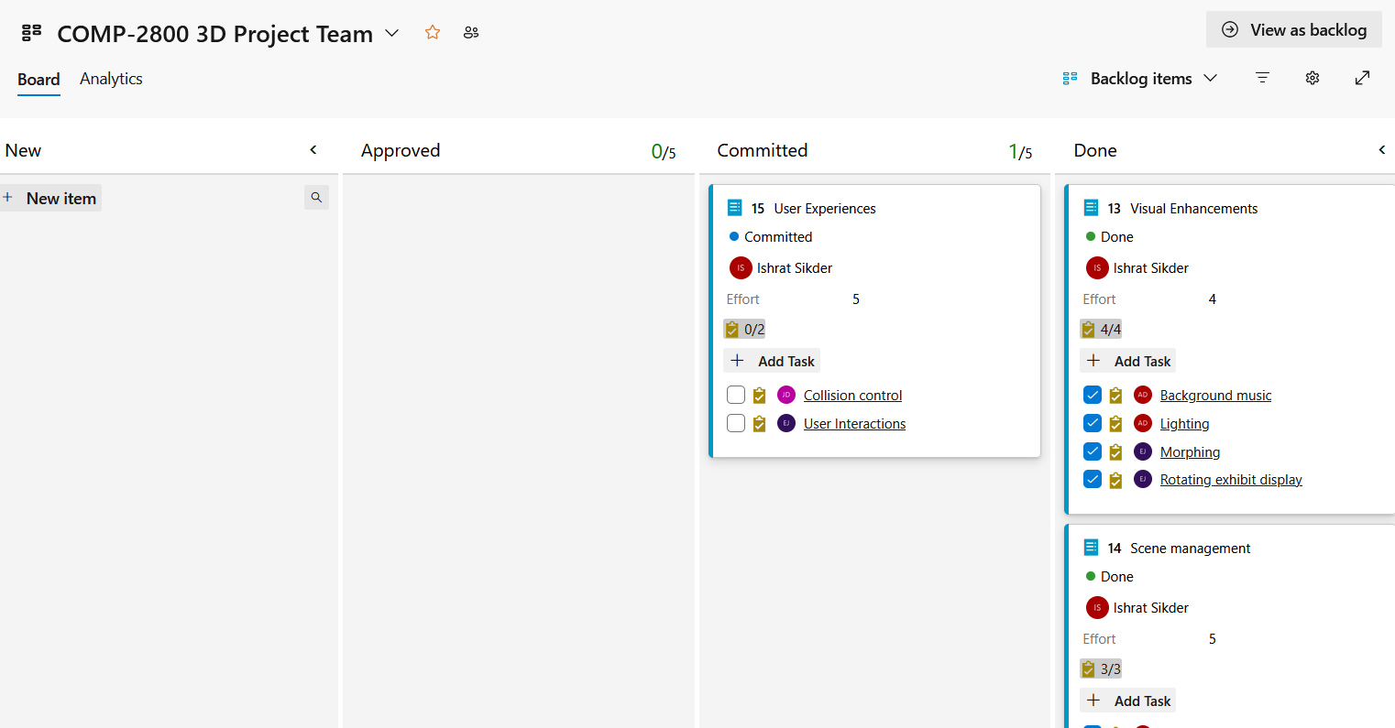

  - Planning and Carrying out the Sprint
We had planed 4 sprints in total to be completed independently by using the waterfall methodology for project management. Each sprint is designed to accomplish a set of tasks to be finished in a certain time frame to ensure smooth progress and efficient project completion.
Sprint 1: 03-10-2025 to 03-16-2025
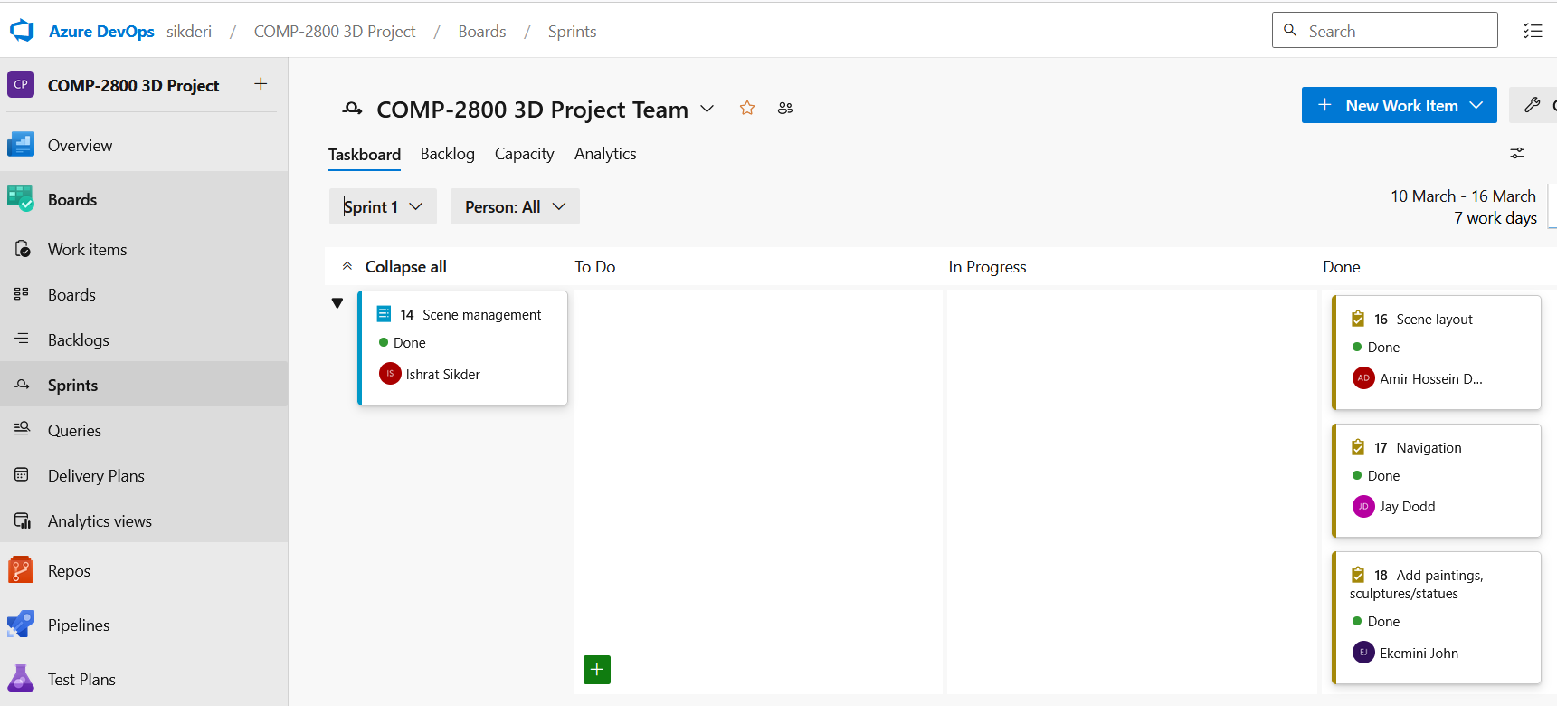
Sprint 2: 03-17-2025 to 03-22-2025
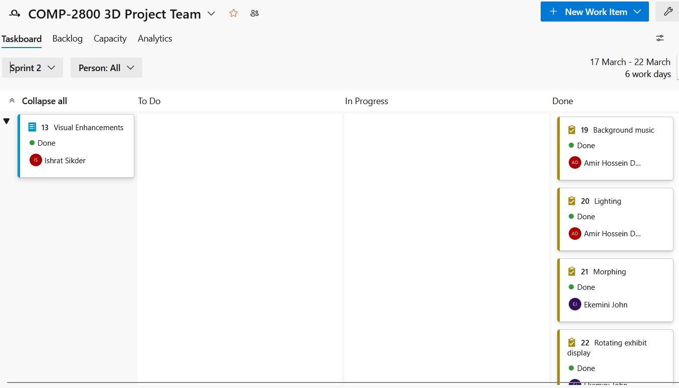
Sprint 3: 03-23-2025 to 03-28-2025
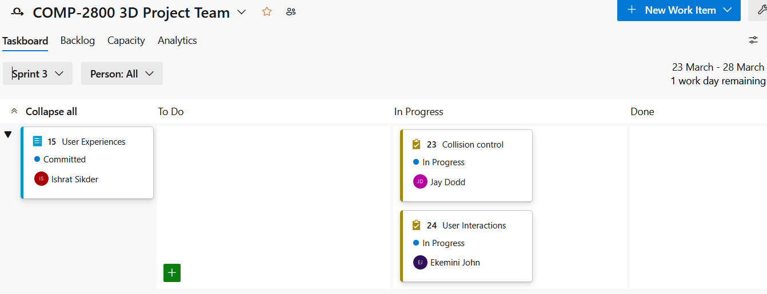
  - Team Management
Instead of forming smaller teams, all developers began working independently on scene management to explore different approaches and determine who could create the best implementation. After evaluating our initial efforts, we then collaborated on enhancing the visuals and refining user controls, assigning specific tasks to team members based on their strengths and expertise. To keep everyone aligned, we held two weekly meetings, typically lasting around 30 minutes, to discuss our progress and any challenges we were facing. In addition, we maintained regular written communication with our Scrum Master to provide updates and address any outstanding issues, ensuring continuous transparency and support throughout the project.
(Object-Oriented) Software Development
  - Identification of Classes
The Project.java program is the core of our Java3D project, serving as the main class that sets up and manages the interactive 3D museum environment.
1. Scene Setup and Rendering
The program initializes a 3D scene using Java3D’s SimpleUniverse, creating a virtual museum room with textured walls, floor, and ceiling. The room is bounded to restrict player movement (X_BOUND, Z_BOUND), and objects like statues, control panels, and a dinosaur are added via helper classes (ProjectObjects, ProjectImages). The scene includes:
- Textured Surfaces: Walls use tiled textures (e.g., ImageWall.jpg) with lighting effects.
- Dynamic Lighting: A point light follows the player’s camera, and toggleable ceiling lights (white/colorful) illuminate the scene.
2. Player Interaction
The class implements MouseListener, MouseMotionListener, and KeyListener to enable:
- First-Person Movement: WASD keys move the camera, with collision detection against objects (defined in OBJECT_BOUNDS).
- Mouse Look: Dragging the mouse adjusts the camera’s yaw (horizontal) and pitch (vertical) angles.
3. Interactive Features
- Clickable Objects: Mouse clicks trigger actions (e.g., toggling animations for statues, playing dinosaur sounds).
- Switches: Two interactive switches control ceiling lights (switch1TG) and background music (switch2TG), with visual feedback (indicator lights).
- Camera Views: Right-clicking objects switches to predefined camera angles (e.g., for observing exhibits).
4. Sound and Animation
- SoundPlayer: Handles background music, footstep sounds during movement, and sound effects (e.g., dinosaur roar, switch clicks).
- Animations: Statues can rotate or levitate when their control panels are clicked, managed via RotationInterpolator and custom Levitation classes.
5. Technical Highlights
- Collision Detection: Uses axis-aligned bounding boxes (OBJECT_BOUNDS) to prevent walking through objects.
- Scene Graph Management: Dynamic lights and objects are added/updated via TransformGroup and BranchGroup.

The ProjectAnimations.java program is responsible for managing dynamic animations and morphing effects in our Java3D museum project. Here’s a breakdown of its key functionalities:
1. Morphing Image Blocks
The core feature is the createMorphImageBlock method, which generates 3D paintings or objects that can morph between different geometric shapes (e.g., transitioning between a 4-sided rhombus and a 64-sided near-circle). Key aspects include:
- Multi-Target Morphing: Creates three morph targets (front, back, and lateral surfaces) with adjustable edge counts (n0, n1).
- Textures and Lighting: Applies textures to front/back faces (e.g., imageFile) and uses Appearance objects for material properties (diffuse/specular lighting).
- Alpha-Based Animation: Uses Alpha objects and MorphingBehavior to smoothly interpolate between shapes over time.
2. Animation Utilities
- Rotation:
  - createRotatingTG attaches a RotationInterpolator to a TransformGroup, enabling continuous rotation (e.g., for statues).
  - Controlled via Alpha objects, allowing pause/resume functionality (toggleAlpha).
- Levitation:
  - createLevitationTG uses a custom Levitation behavior class to make objects float up/down between minOffset and maxOffset.
3. Technical Implementation
- Geometry Generation:
  - createMorphTargetForFace builds front/back faces as TriangleStripArray with normals and texture coordinates.
  - createLateralMorphTarget constructs the sides of morphing objects, ensuring seamless transitions.
- Parametric Shapes: For 4-sided targets, a parametric approach creates rhombus-like shapes; higher sides use polar coordinates for circular approximations.
4. Integration with Scene
- Interactive Control: Morphing and animations can be toggled via user input (e.g., clicking switches in Project.java).
- Performance: Behaviors like Levitation use WakeupOnElapsedTime to optimize updates, bounding volumes (BoundingSphere) to limit processing scope.

The ProjectImages.java program handles the creation and placement of static and morphing image blocks (e.g., paintings) in our Java3D museum project. Here’s a structured explanation of its purpose and functionality:
1. Static Image Blocks
The createImageBlock method generates non-animated 3D paintings or displays:
- Geometry: Uses a Box primitive with defined width, height, and thickness to create a rectangular frame.
- Textures: Applies textures (e.g., ImageMonaLisa.jpg) to the front/back faces via TextureLoader. The flip parameter swaps front/back textures if needed.
- Appearances:
  - Front face: Displays the loaded image texture.
  - Back/sides: Use a default gray material (Color3f(0.8f, 0.8f, 0.8f)) with lighting properties.
- Positioning: Places the block in the scene using Transform3D for translation (position) and rotation (rotation).
2. Morphing Gallery Images
The addGalleryImages method constructs a collection of dynamic, shape-shifting paintings by leveraging ProjectAnimations.createMorphImageBlock:
- Morphing Targets: Each painting morphs between a 4-sided rhombus and a 64-sided near-circle for smooth transitions.
- Placement:
  - Back Wall: Three paintings (e.g., Mona Lisa, Starry Night) positioned at z = -49 (aligned with the room’s back wall).
  - Side Wall: One painting (ImageAbstract.jpg) rotated 90° (Math.PI/2) to face inward.
  - Front Wall: Three flipped paintings (e.g., Twilight, Ship) at z = 49.

The ProjectObjects.java program serves as the central hub for creating, configuring, and managing all 3D objects in your Java3D museum project. It handles model loading, appearance customization, positioning, and interactive behaviors.
1. Model Loading & Preprocessing
- loadModel(String filePath):
  - Loads OBJ 3D models (e.g., statues, furniture) using Java3D's ObjectFile loader.
  - Preprocesses files to fix material issues (replaces o with g in OBJ files).
  - Logs errors for missing files or textures.
- Helper Methods:
  - readFileToString: Reads OBJ files into strings.
  - preprocessOBJ: Ensures material compatibility by modifying OBJ syntax.
2. Appearance & Lighting
- createAppearance(String objectName):
  - Applies textures (e.g., objectName.jpg) and configures material properties (ambient/diffuse/specular colors, shininess).
  - Enables lighting interaction via Material and TextureAttributes.
- Material Utilities:
  - createLightingMaterial(): Default material for objects.
  - createLightingMaterial(Color3f, ...): Customizable materials (e.g., metallic statues, glossy floors).
3. Object Creation & Placement
Each method (e.g., addPotAt, addRobotAt) generates a BranchGroup for a specific 3D object:
- Geometry: Loads models (e.g., pot.obj, robot.obj).
- Transformations: Positions, scales, and rotates objects using Transform3D.
- Hierarchy: Combines objects into scene graphs (e.g., robot parts with rotating heads).
Key Objects:
- Statues: addManAt, addWomanAt apply rotation/levitation animations via ProjectAnimations.
- Interactive Elements:
  - Switches/Buttons: addSwitchAt, addControlButtonAt tag objects with userData for click actions (e.g., "trex-sound").
  - Indicators: addIndicatorAt toggles colors (red/green) for state feedback.
- Environment: Walls, floors, ceilings, lights, and speakers are positioned procedurally.
4. Special Features
- Robot Assembly:
  - Splits robot.obj into parts (body, wires, accents) and applies distinct materials.
  - Adds a RotationInterpolator for head movement, controlled via robotHeadRotator.
- Animation Integration:
  - Statues use TransformGroup hierarchies for combined rotation (manRotationTG) and levitation (manLevitationTG).
5. Scene Composition
- addObjects():
  - Constructs the entire museum layout by calling object-placement methods.
  - Positions items like T-Rex sculptures, control panels, and ceiling lights using coordinates (e.g., xLeft, ceilingY).
  - Compiles the BranchGroup for performance optimization.

The SoundPlayer.java program manages all audio playback in our Java3D museum project, handling background music, sound effects, and interactive audio triggers. Here's a breakdown of its functionality:
1. Audio Clip Management
- Initialization: Loads four key audio files in the constructor:
  - MuseumSoundEffect.wav: Ambient background music (looped continuously)
  - footsteps.wav: Footstep sounds during player movement
  - T-rex-roar.wav: Dinosaur roar effect (triggered interactively)
  - switchClick.wav: Button/switch feedback sound
- Error Handling: Catches and prints exceptions for missing/unsupported files (UnsupportedAudioFileException, IOException, LineUnavailableException).
2. Core Functionality
Background Music Control
- playMuseumSound(): Starts looping the ambient museum soundtrack from the beginning.
- pauseMuseumSound() / resumeMuseumSound(): Pauses or resumes playback.
- toggleMuseumSound(): Switches between play/pause states (used for UI controls).
Sound Effects
- Footsteps:
  - startFootsteps(): Loops footsteps while the player moves.
  - stopFootsteps(): Stops playback when movement ceases.
- Interactive Sounds:
  - playTrexRoar(): Plays a 6-second T-Rex roar with auto-stop via Timer.
  - playSwitchClick(): Plays a 250ms switch click sound (trimmed to start at frame 5980 for optimal feedback).
3. Technical Implementation
- Clip Handling: Uses javax.sound.sampled.Clip for low-latency playback.
  - setFramePosition(0): Rewinds audio before replaying.
  - loop(Clip.LOOP_CONTINUOUSLY): For seamless background music/footsteps.
- State Tracking: isPlayingBack boolean tracks background music state.
4. Integration with Project
- Triggered by:
  - Player movement (Project.java's updateMovement() calls footstep methods).
  - UI interactions (switch toggles, button clicks trigger playSwitchClick()).
  - Exhibit interactions (T-Rex roar via playTrexRoar()).
- Performance: Short sounds (clicks) play instantly; longer sounds (roar) use Timer to avoid overlapping.
  - Software Design with Class Diagram(s)
Click here: Project_class_diagram
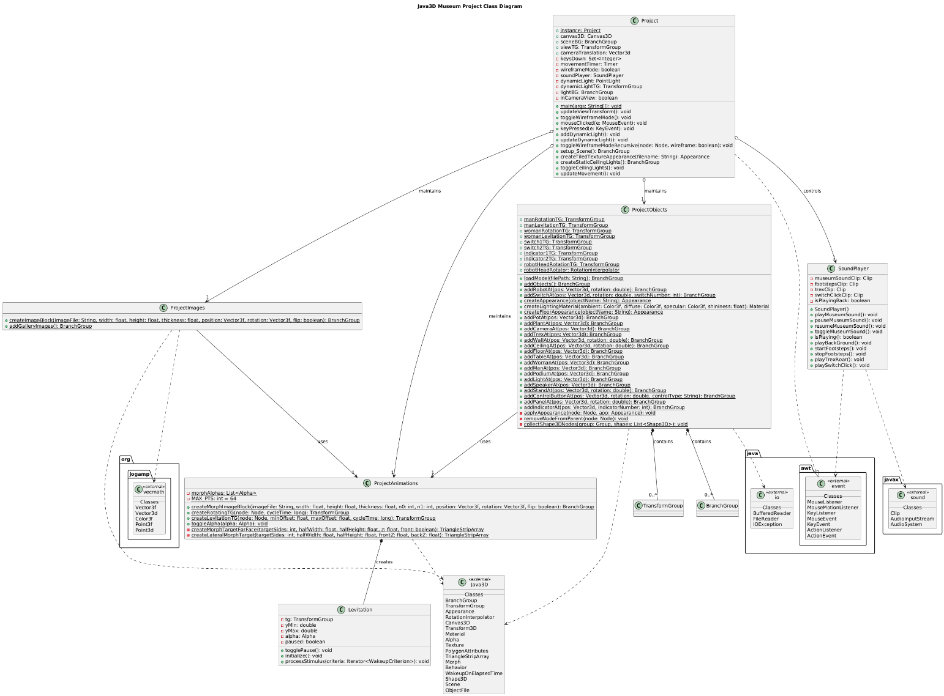
  - Techniques of Implementation
Programming Language: Utilizing Java along with the Java3D library for rendering 3D graphics.
Documentation: Adhering to naming conventions and providing appropriate documentation through comments in the code.
Project Management: Adopting the Scrum framework for project management, which includes sprint planning, review, and retrospective meetings to enhance team communication and track progress effectively.
Testing: Implementing unit tests, integration tests, and automated testing to ensure the software’s stability and correctness.
Continuous Integration/Continuous Deployment (CI/CD): Establishing automated build and deployment pipelines to streamline the development process and minimize the time required to move from development to production.
User Interface and User Experience (UI/UX): Crafting an intuitive and visually appealing interface that enables users to interact with the gallery/museum efficiently.
Performance Optimization: Employing techniques such as level of detail (LOD) to enhance the performance of the simulation, particularly when rendering complex scenes.
  - Software Testing and Operation:
Sound Performance Evaluation: Assess the synchronization between visual elements and audio in the Java 3D application. Pay close attention to the coordination of sound effects—like those for rotating exhibits—to ensure they align perfectly with the visual representations. Check that sound effects are triggered at the correct moments and play seamlessly, without any noticeable delays or discrepancies in visuals.
Navigation Assessment: Examine the navigation controls—including both mouse and keyboard inputs—to confirm users can traverse the 3D environment smoothly and intuitively. Ensure that movements are responsive, precise, and consistent across various input devices. Test the functionality that allows users to switch between different camera perspectives easily and ensure that the navigation controls are clearly documented and user-friendly.
Error Handling Assessment: Evaluate how the software responds to potential error scenarios, such as incorrect key inputs or unexpected key events. Ensure that key listeners function reliably under these conditions, gracefully handling errors without crashing or exhibiting erratic behavior. For example, verify that the key listeners manage invalid key inputs correctly.
Collision Detection Testing: Test the collision detection and response mechanisms to verify that 3D objects interact with one another in a realistic manner, free from glitches. Check that objects can collide from various angles and at different speeds, producing the appropriate feedback—such as bouncing or breaking. Ensure that collision detection remains accurate and efficient, even in complex scenes containing numerous objects, and that the physics engine performs well under load.
Discussions and Recommendations
  - Discussion about the project
Meeting 1: Project Kickoff
Agenda: brainstorming features of project + team roles division
Discussion:
- Members brought up different ideas for the project and discussed the limitations and executability in consideration to our skill level + time
- Discussed for each idea how would we incorporate the project requirements (different user interactions, morphing, types of objects to include)
- Agreed on primary roles for scrum practice
  - Ishrat: scrum master – responsible for management of team work, planning, communication, scrum framework management, report writing
  - Amir: lead developer, responsible for technical decisions, implementing specific features and functionalities.
  - Ekemini: implementing specific features and functionalities.
  - Jay: implementing specific features and functionalities.
- Finalized the theme to be museum/art gallery and agreed on the possible ways to fulfill the requirements
  - Skybox or textured surface for the environment “room”
  - Ambient sound for background music + footstep sound for user moving
  - Lights around the room and/or emitting from objects
  - Paintings as image mapped textures
  - Rotating display for animation
  - Click on painting for info pop-ups
  - Morph some of the sculptures
  - Keyboard input for navigation (normal walking mode + cctv view)
Meeting 2: Sprint planning
Agenda: product backlog, goals, task estimation
Discussion:
- Could not use azure devops for some errors regarding access so going with jira for now
- Come up with backlogs and brief descriptions and assign a developer
  - Regardless of who is assigned all developers are free to work on different aspects, especially for the initial environment set up
- Define a rough deadline for each set of task category aka sprints
Meeting 3: Sprint review
Agenda: review completed tasks, collect feedback
Discussion:
- Show everyone’s progress and review completed tasks, tasks changed from original planning, and those yet to be completed
- Discuss what difficulties each developer is facing
Meeting 4: Deployment
Agenda: show final demo to group, save all files on github, record video
Discussion:
- Discuss how to record the video and all the features we must show and in which order; whether to narrate or do captions
- Run project in all member’s device for check up
- Discuss with members progress of term report and anything needed from members for its completion
- Review contributions charts
  - Recommendation for better practices
Clear and concise requirements: Make sure the project requirements are well-defined, documented and frequented revisited during meeting. This will help avoid misunderstandings and facilitate better design and implementation in a faster rate. Also, define acceptance criteria for each task to determine when features are complete.
Regular code reviews: Conduct regular code reviews to identify potential issues, share knowledge, and maintain code quality. This practice helps to reduce bugs and improve overall software quality.
Sprint Planning, review and retrospectives: Conduct effective sprint planning meetings to prioritize tasks and break down user stories into manageable tasks. Also, conduct sprint reviews to demo completed features and retrospectives to identify areas for improvement.
Documentation: Maintain wiki to document user guides along with setup instructions.
Communication: encourage team members to keep fellow developers – as well as scrum master- updated on their progress and uploading their work on github consistently.
Regularly Evaluate and Adapt: Conduct regular retrospectives to review what is working well, identify areas for improvement, and determine any necessary adjustments to processes or practices.

Conclusion
In conclusion, this Java3D Virtual Art Museum project has been an engaging exploration of 3D graphics, blending our passion for art with technical programming skills. Through collaborative development, we honed our expertise in Java3D’s scene graph architecture, interactive design, and lighting/texture mapping while creating an immersive gallery space. The final product—featuring animated sculptures, dynamic exhibits, and realistic navigation—demonstrates how technology can transform art appreciation into an interactive experience. This project not only deepened our understanding of virtual environments but also highlighted the potential of VR for education and cultural preservation. We hope our museum inspires others to reimagine the intersection of art and technology.
References
Appendix A
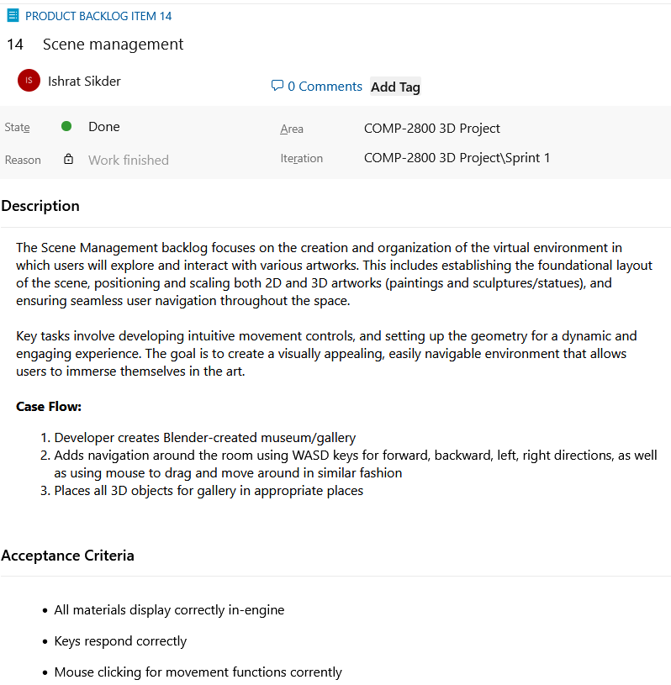
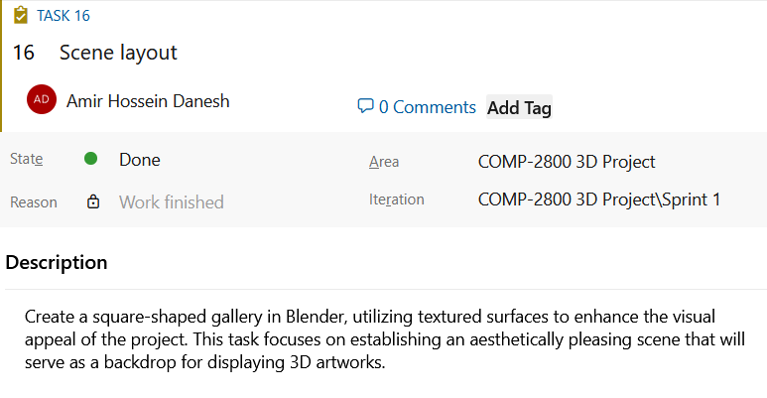
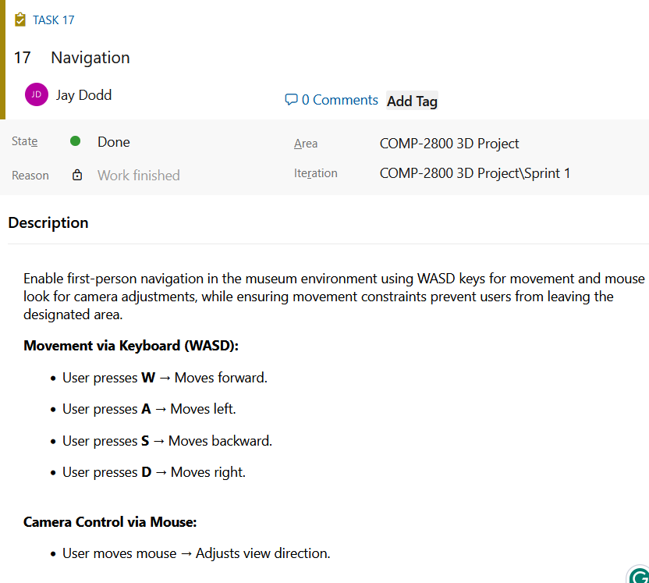
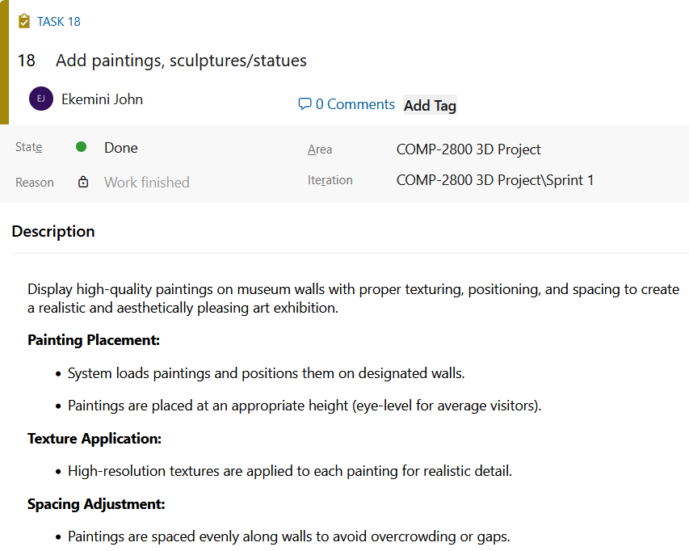
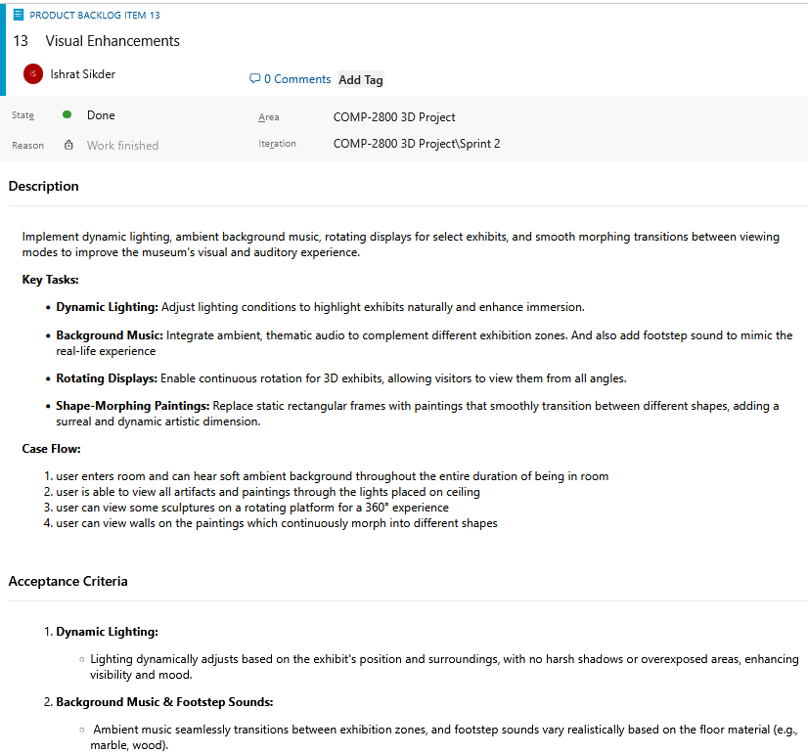
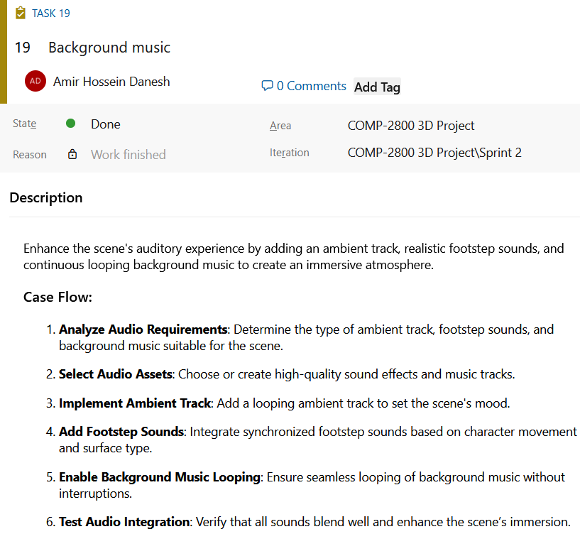
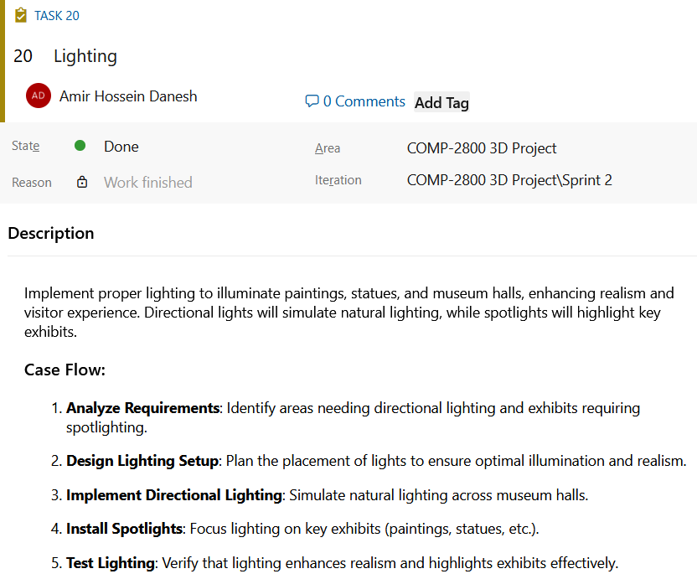

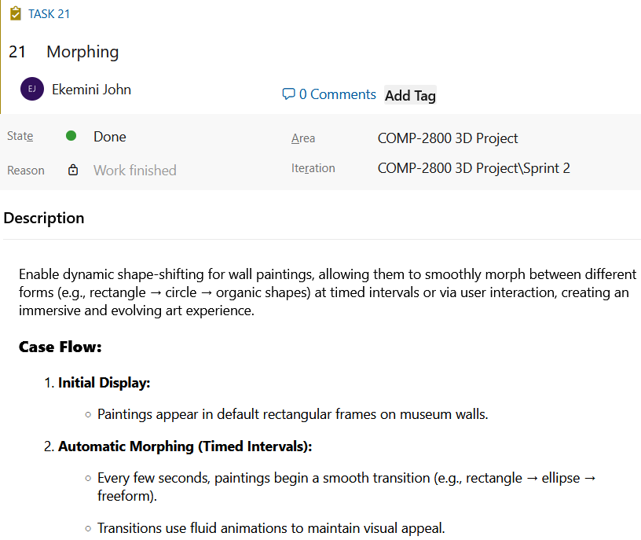
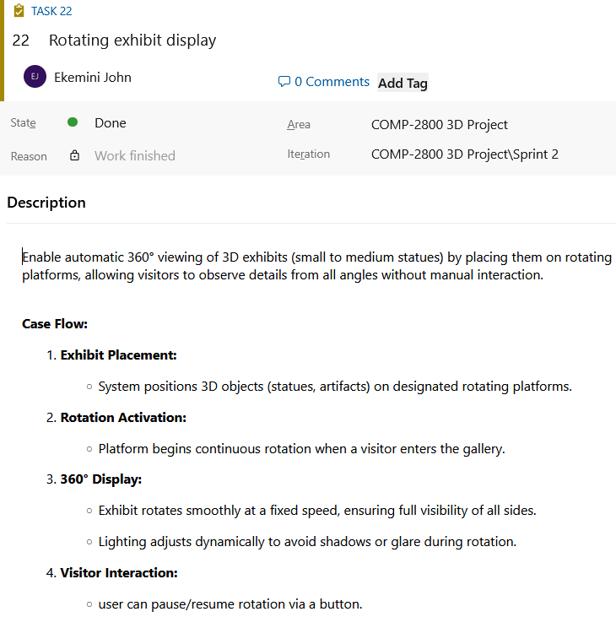
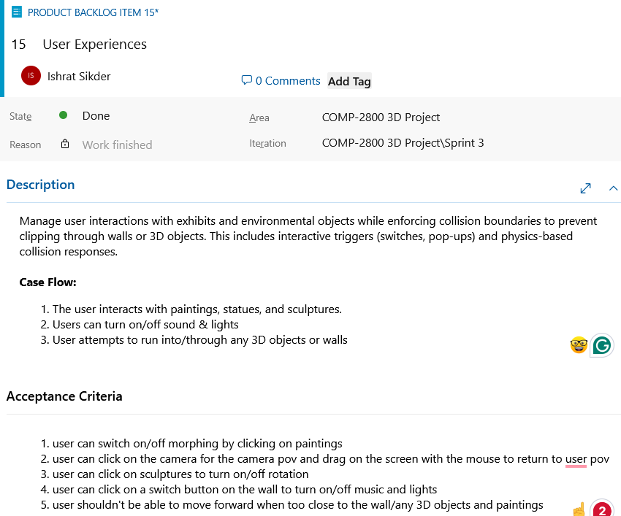
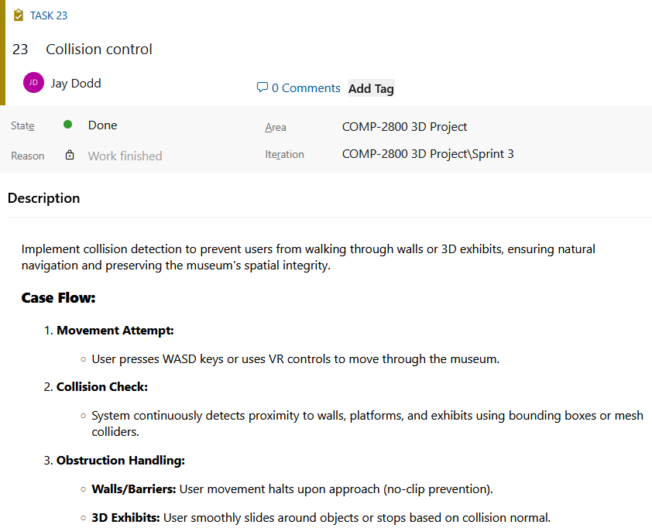
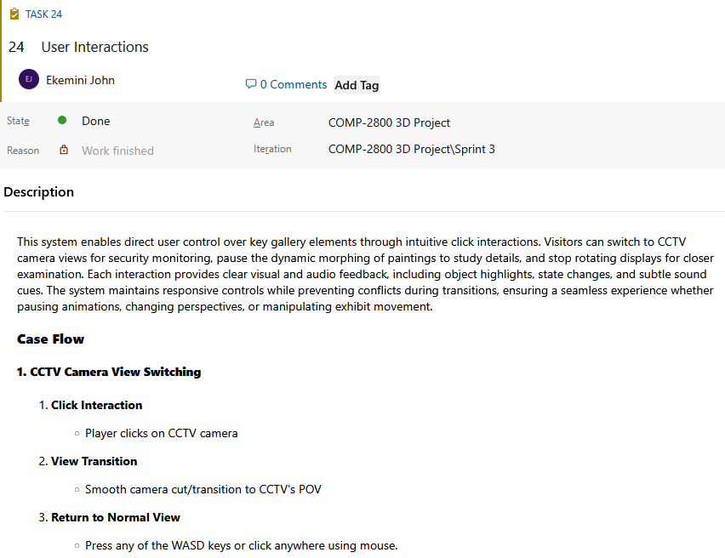
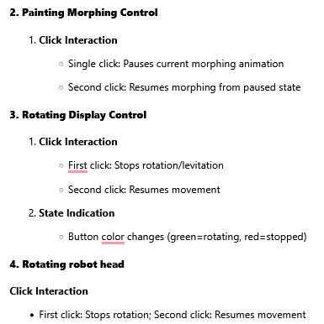
Appendix B
Ishrat Sikder | Amir Danesh | Jay Dodd | Ekemini John
*Table attached in submission folder
Appendix C
Ishrat Sikder | Amir Danesh | Jay Dodd | Ekemini John
*Table attached in submission folder

